**Project 1:Deploying a website on AWS EC2 Instance**

* **vpc created as nithinvpc**

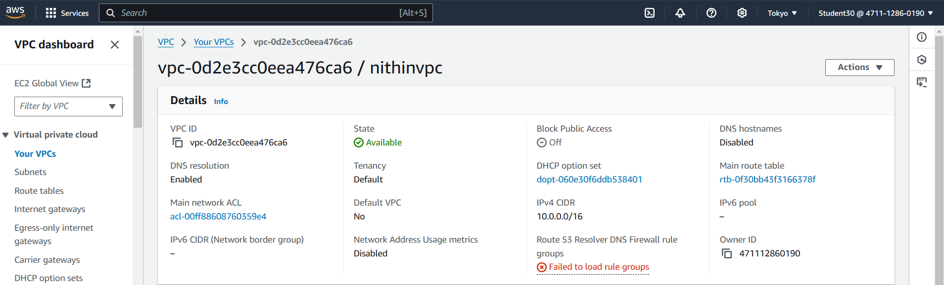

* **Internet gateway created as nithingateway**

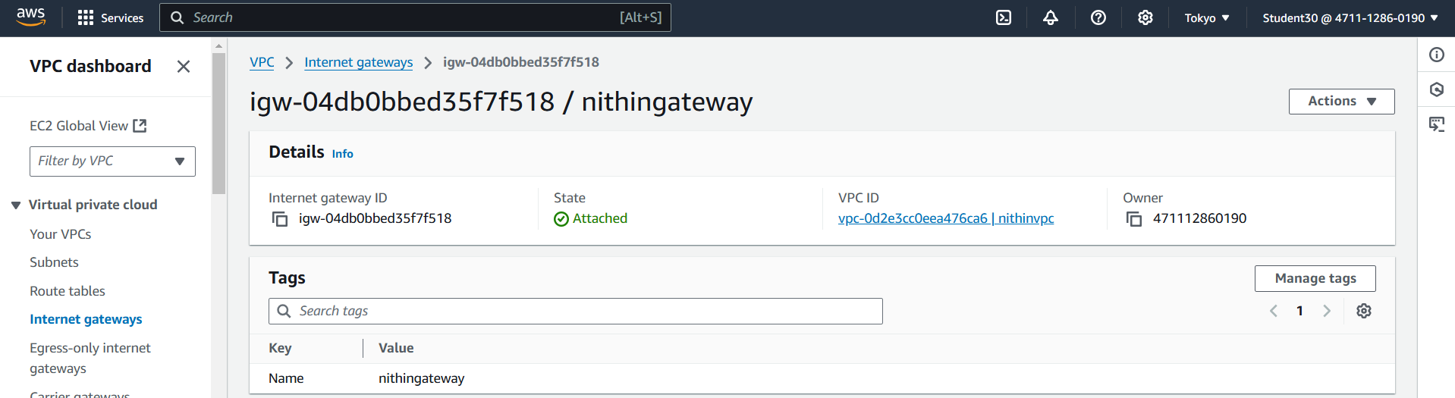

* **Subnet created as nithin-subnet2**

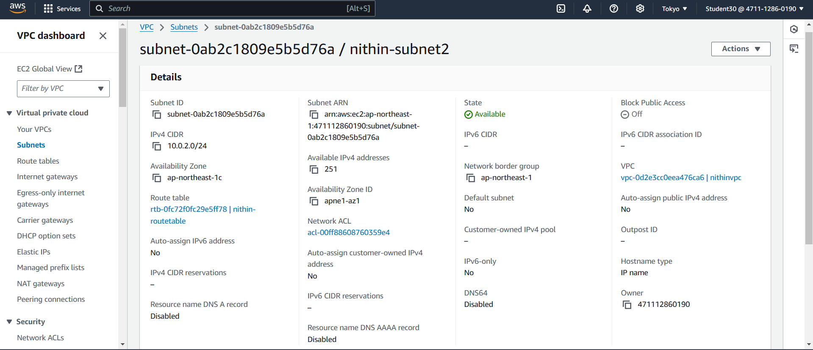

* **Subnet created as nithin-subnet1**

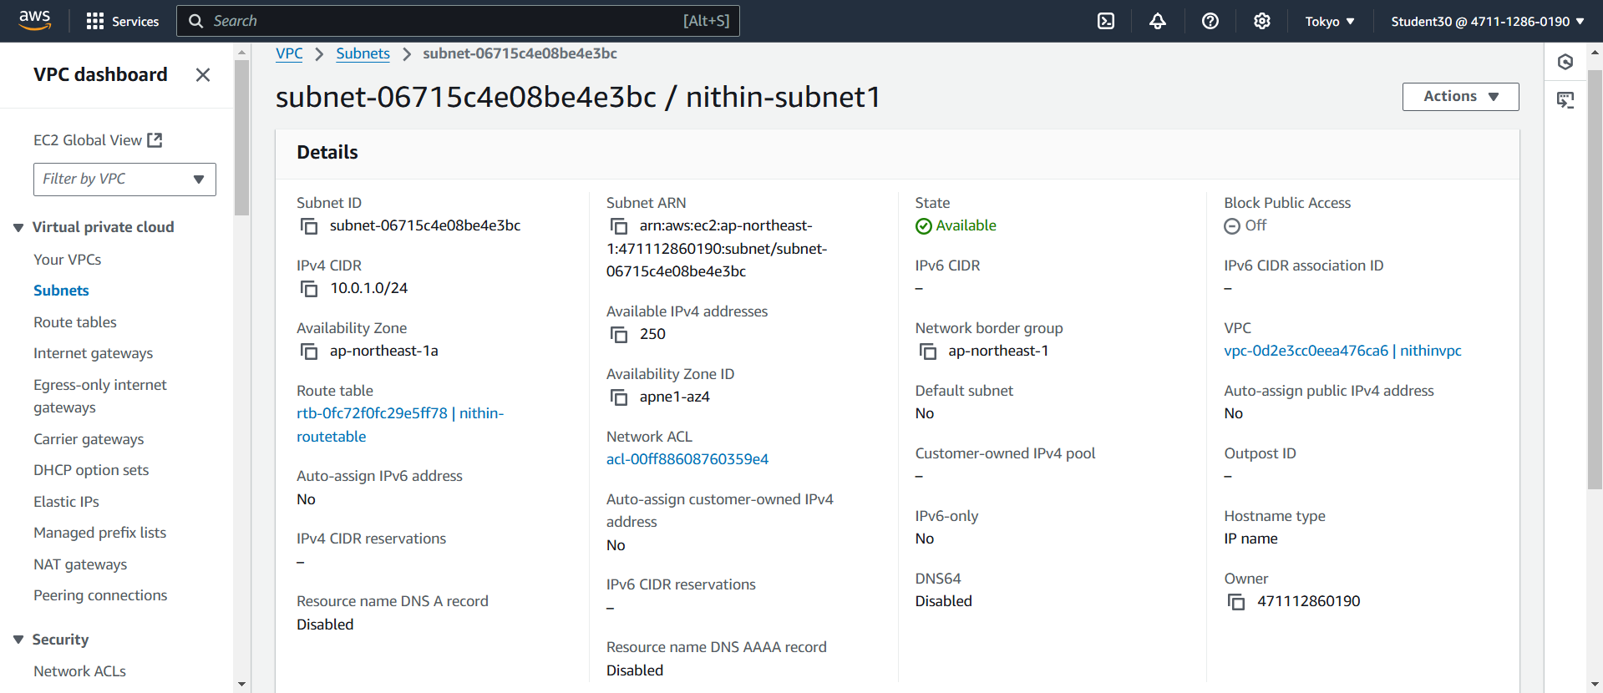

* **Route table created as nithin-routetable**

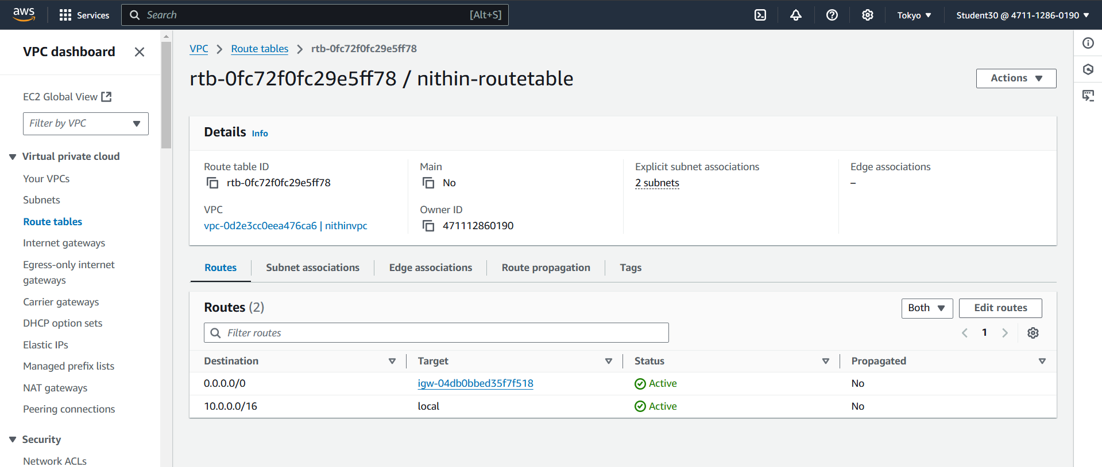

* **Instance server created as nithin-server**

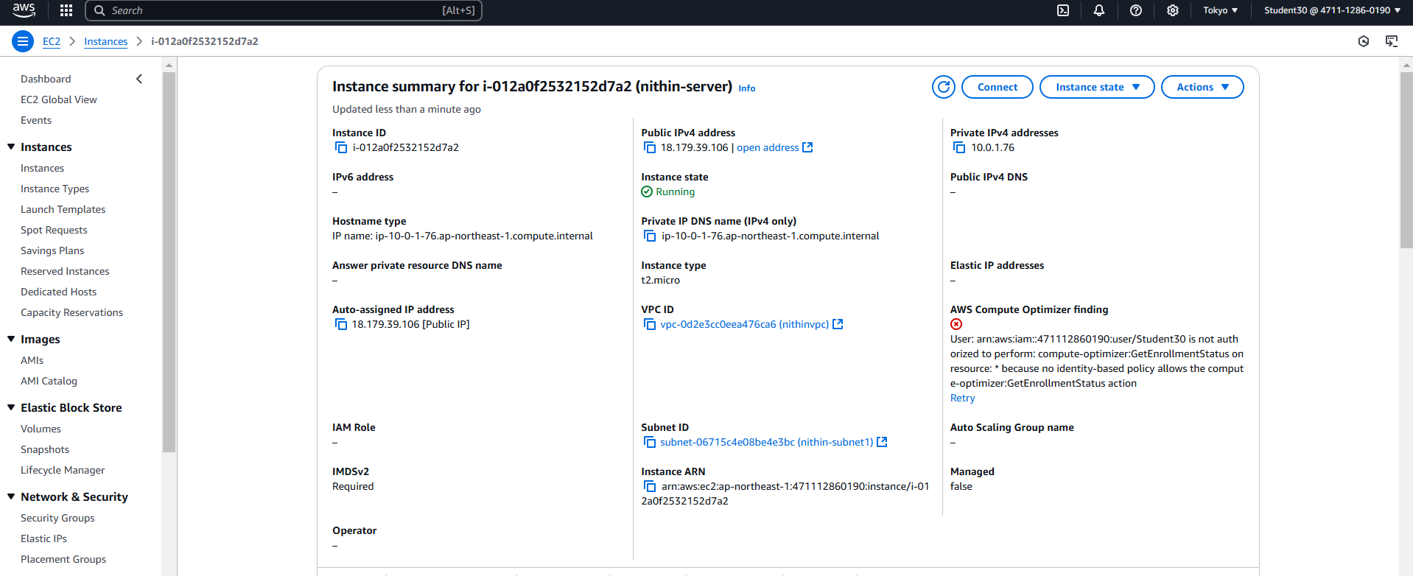

* **Connect to instance(SSH client)**

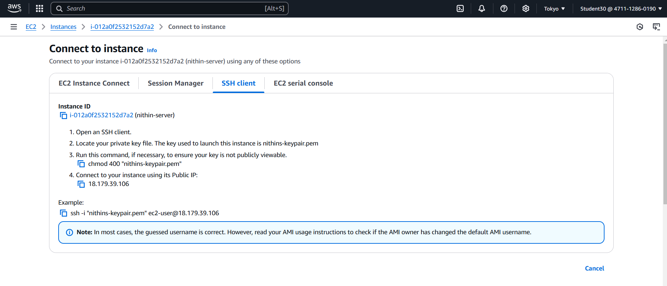

* **Command prompt**

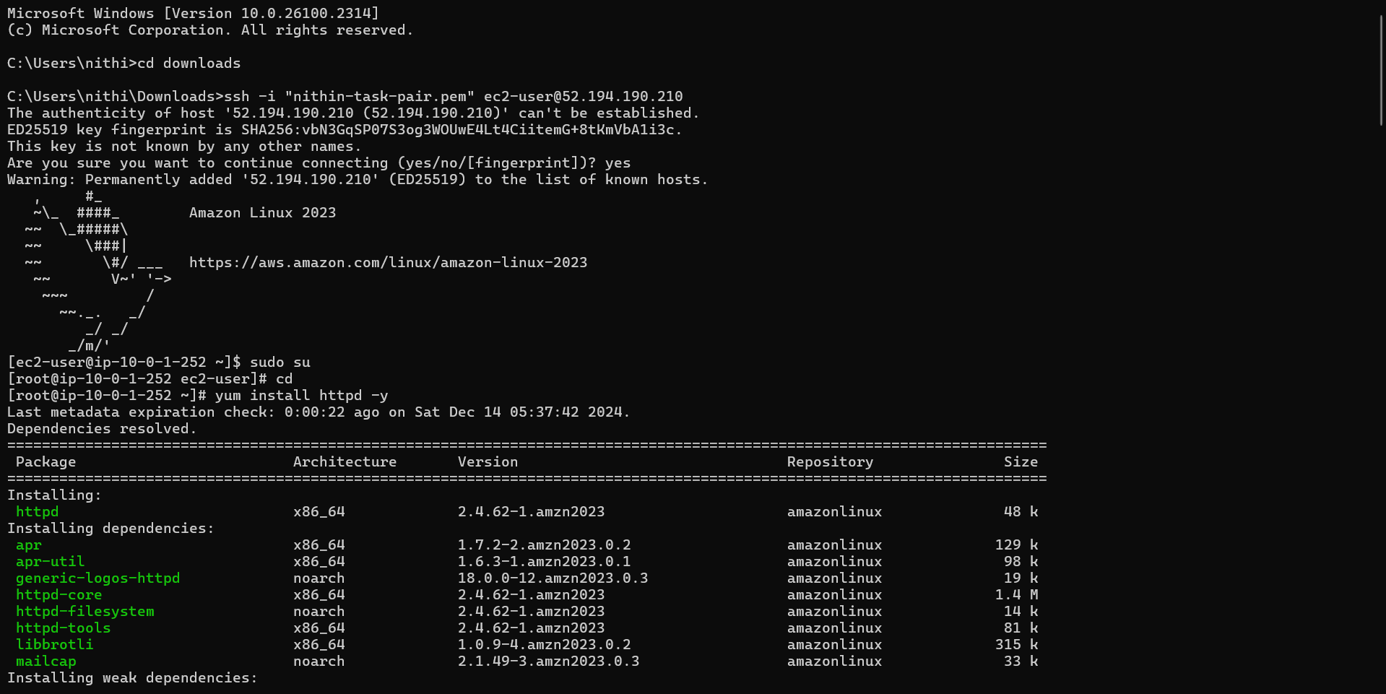

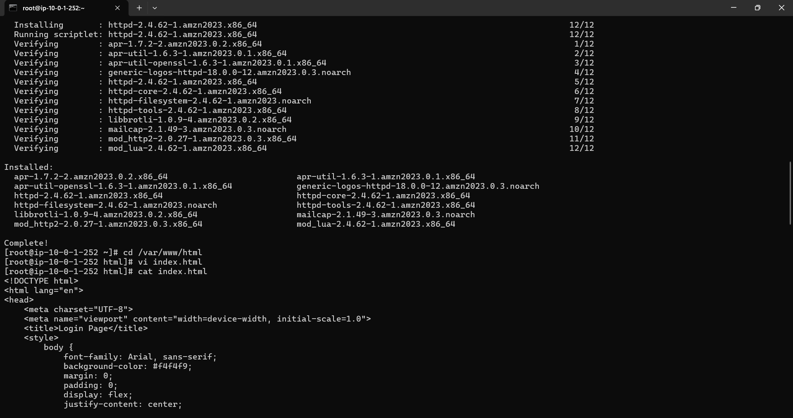

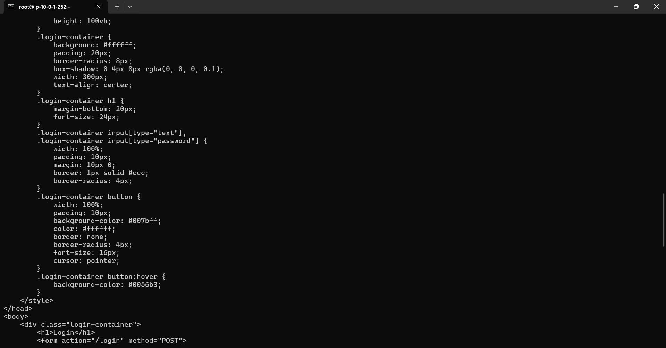

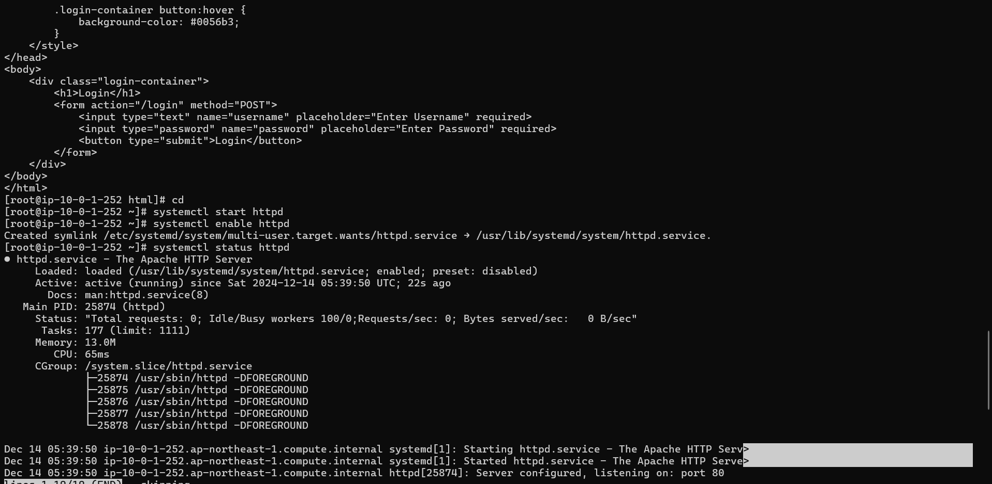

* **Final output**

